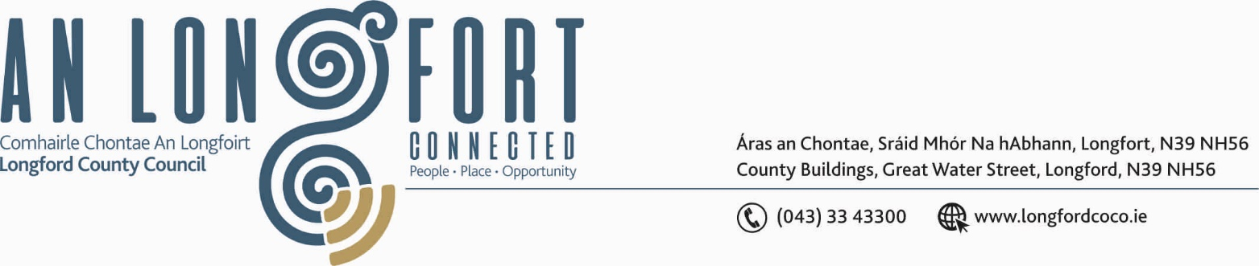

GRANARD MUNICIPAL DISTRICT

Corporate Affairs,
Aras an Chontae,
LONGFOIRT.

19th September 2018.

To: Each Member of Granard Municipal District.

Dear Member,

You are requested to attend Meeting of Granard Municipal District to be held in
Granard Community Library on Tuesday, 25th September 2018 at 3.30 p.m. to transact business, as set out on the Agenda hereunder.
A presentation will be held at 5.00 p.m to the Granard/Ballymore U14 Team – Feile Peile na nOg Winners 2018.

Yours sincerely,
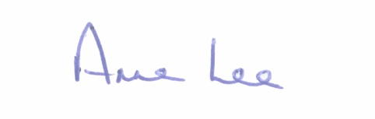

_______________
Anne Lee,
Meetings Administrator.

AGENDA

Prayer before meeting.

1. Confirmation of the Minutes of Granard Municipal District Meeting held on the 24th July 2018 – copy enclosed.

2. Matters arising from Minutes.

3. Area Engineer’s Progress Report.

4. Notices of Motions submitted by Councillors, as listed hereunder. –

Councillor P.J. Reilly

“I wish to put a motion forward to the meeting for the Council to erect a sculpture in Granard dedicated to the late Larry Cunningham and Brendan O'Reilly, as these two men brought international recognition to our town.”

Councillor Michael Carrigy.

“I call on Longford County Council to support the extension of the footpaths in Aughnacliffe to connect the estates and the various community facilities.”

Councillor Pauric Brady.

“That Murphy’s Cross in Drumlish be formally named “Murphy’s Cross”.

5. Correspondence – circulated.

- Correspondence received from Irish Water regarding regarding the delay in completion of works at Drumure DMA, between Killeenatruan Village and Killeter Crossroads.

- Correspondence received from Cllr Joe Flaherty to Minister of State Kevin Moran regarding Boomerang Hickstead Trophy

6. Reception of Deputation from the Toneywarden, Ferriskill and Granardkille areas regarding water supply.

::::::::::::::::::::::::::::::::::::

